**COCA ANALYSIS (CHART)**

**Shivansh Mishra**

**17BCB0112**

**Date:05.12.19**

1. Search : MESSI

RESULTS:

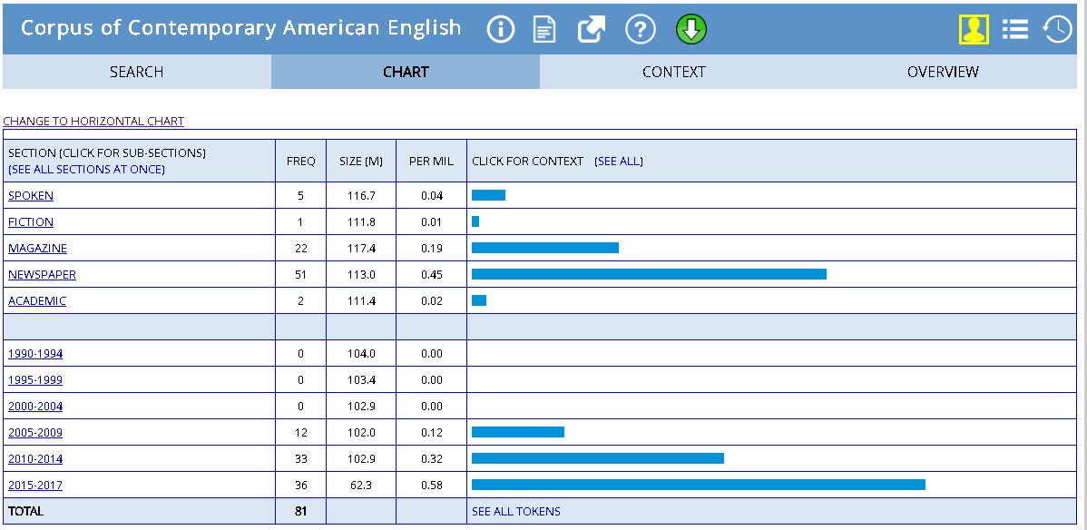

Most mentioned in: 2015-17

Probable reasons: Ballon D’Or winner (Best footballer in Europe)

Comparison between Messi and Ronaldo:

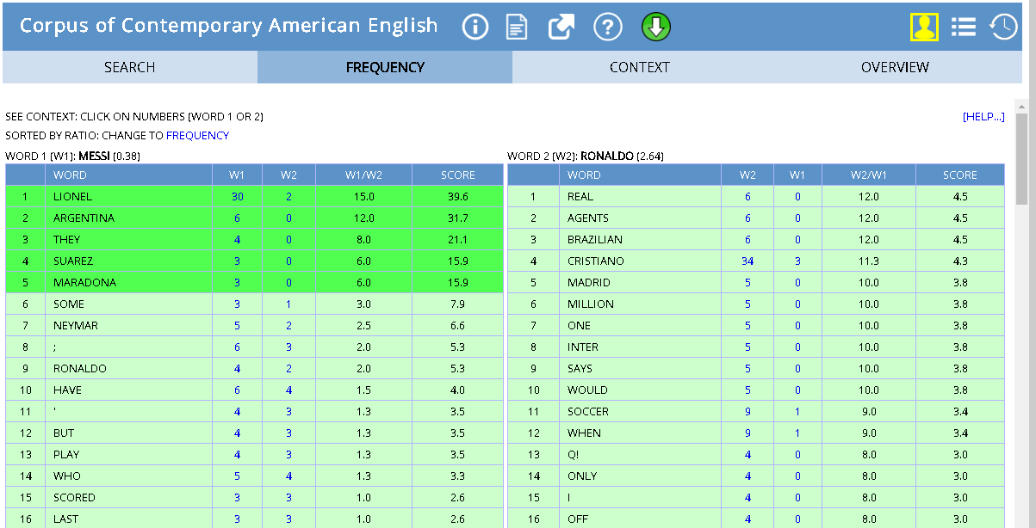

NOTE: Ronaldo generates more mentions due to the presence of another individual apart from Cristiano, the older Brazilian Ronaldo, as can be inferred from the results

1. Collocates:

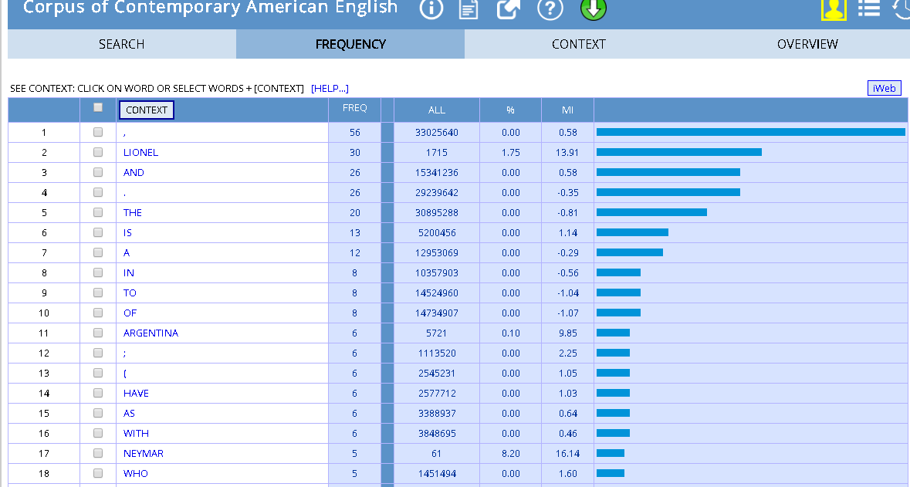

1. KWIC:

